EXECUTION OF NEXT WORD PREDICTION FILE:

1. Activation.bat, final.py, requirements.txt are placed in C:\ drive.

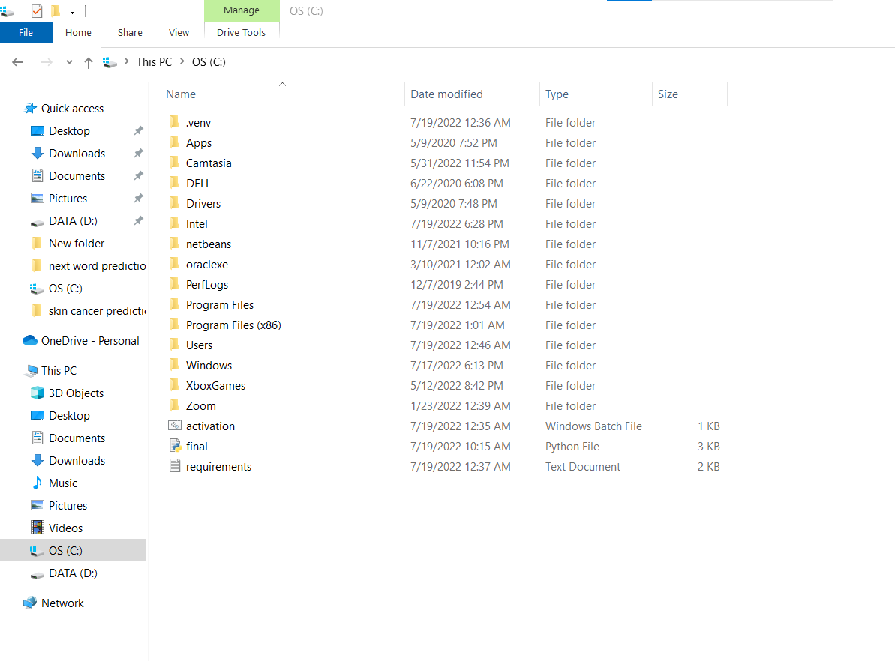

1. Activation.bat is opened.
2. If activation.bat file isn’t getting executed, then right click->Properties->check the unblock check box.

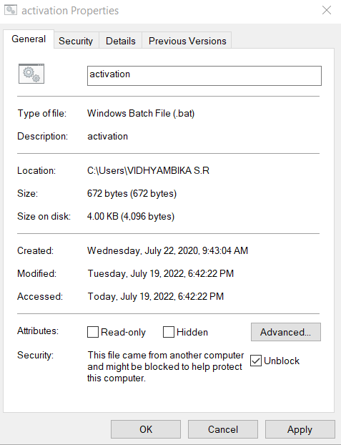

1. Upon activation.bat execution, command prompt will automatically get opened and requirements.txt will automatically get executed and libraries mentioned in this file will be automatically installed.
2. After installation, final.py will automatically get executed and webapp(implemented using streamlit) of next word prediction will get opened in system’s default browser.

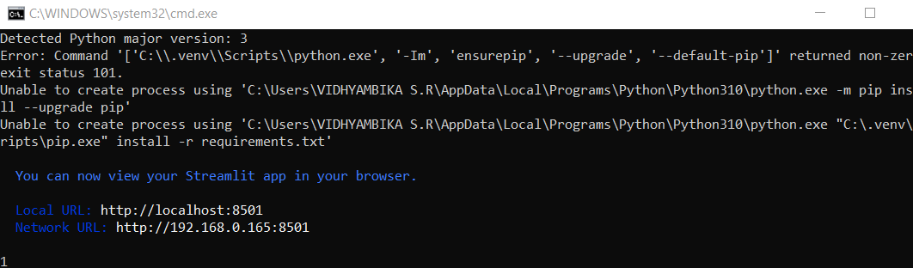

1. If module not found error is displayed in the browser, then in command prompt opened before the following commands are to be typed:

pip install streamlit

pip install pynput

After installation, running the activation.bat file will open web app in system’s default web browser and following screen will be displayed.

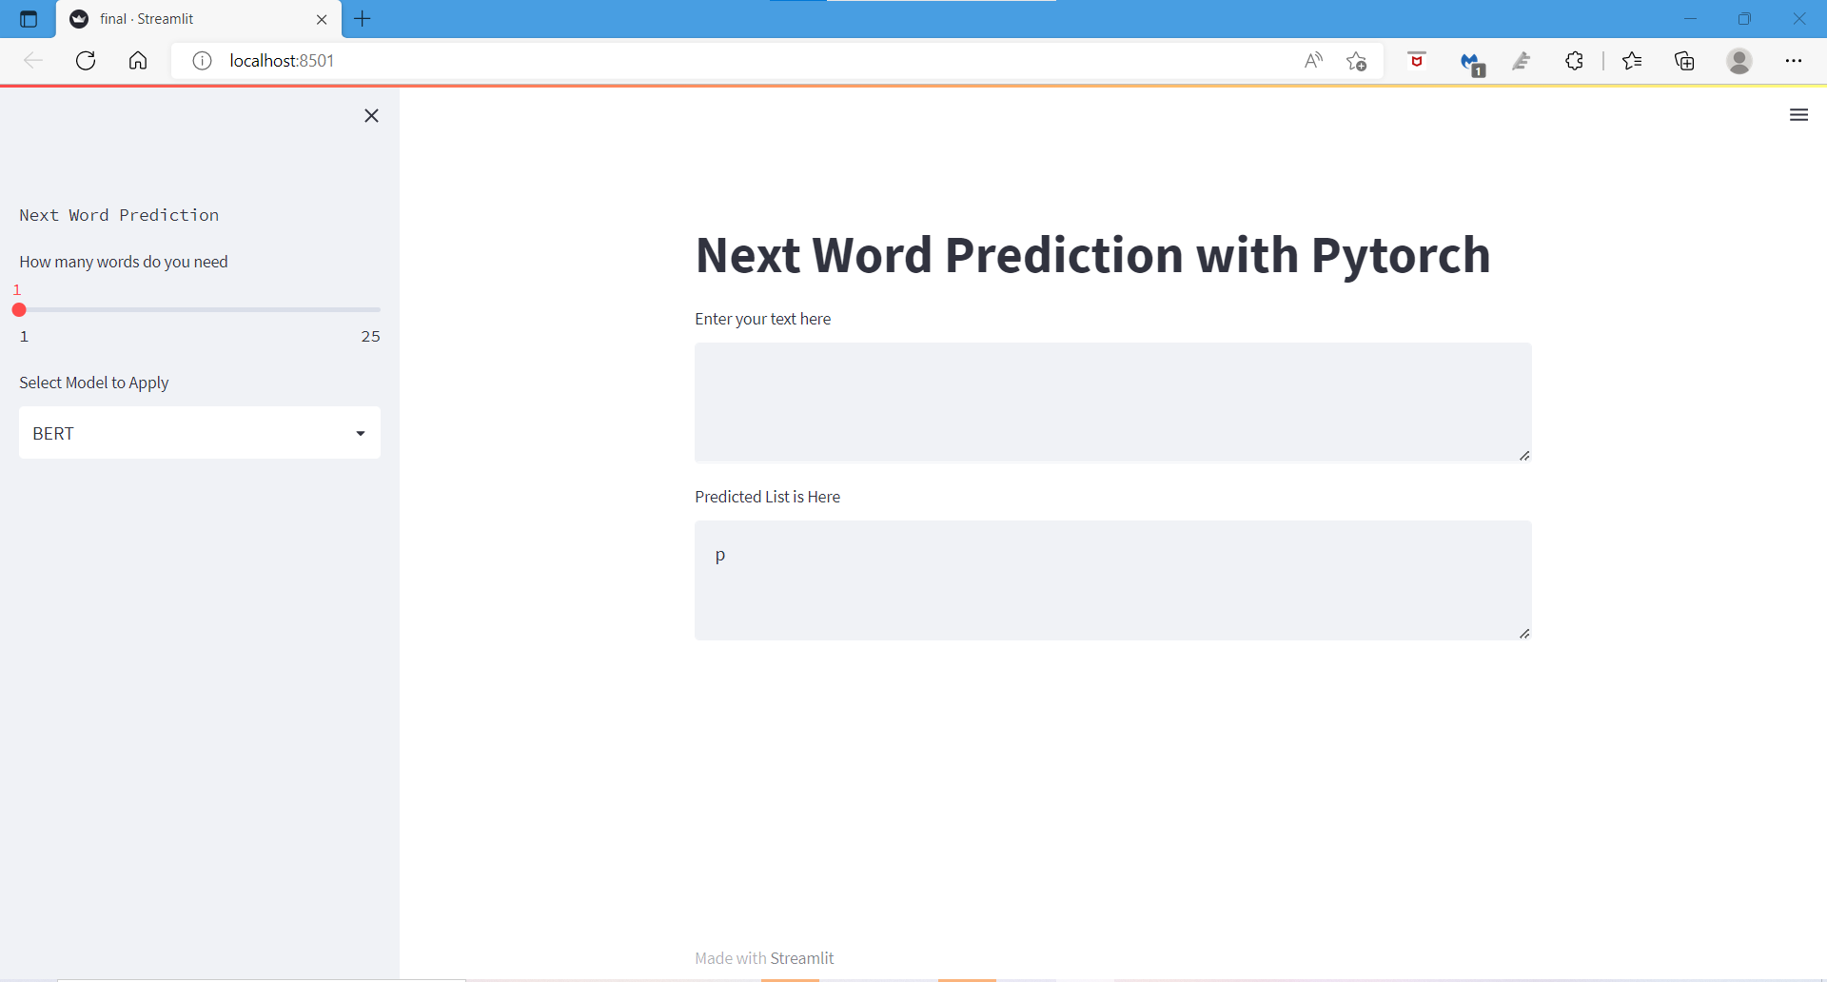

1. Input text say “hello how are” is typed. This project is case insensitive, so we can type capital lettered words also.
2. No of words is selected in the slider. Pressing Ctrl+Enter will display the output.

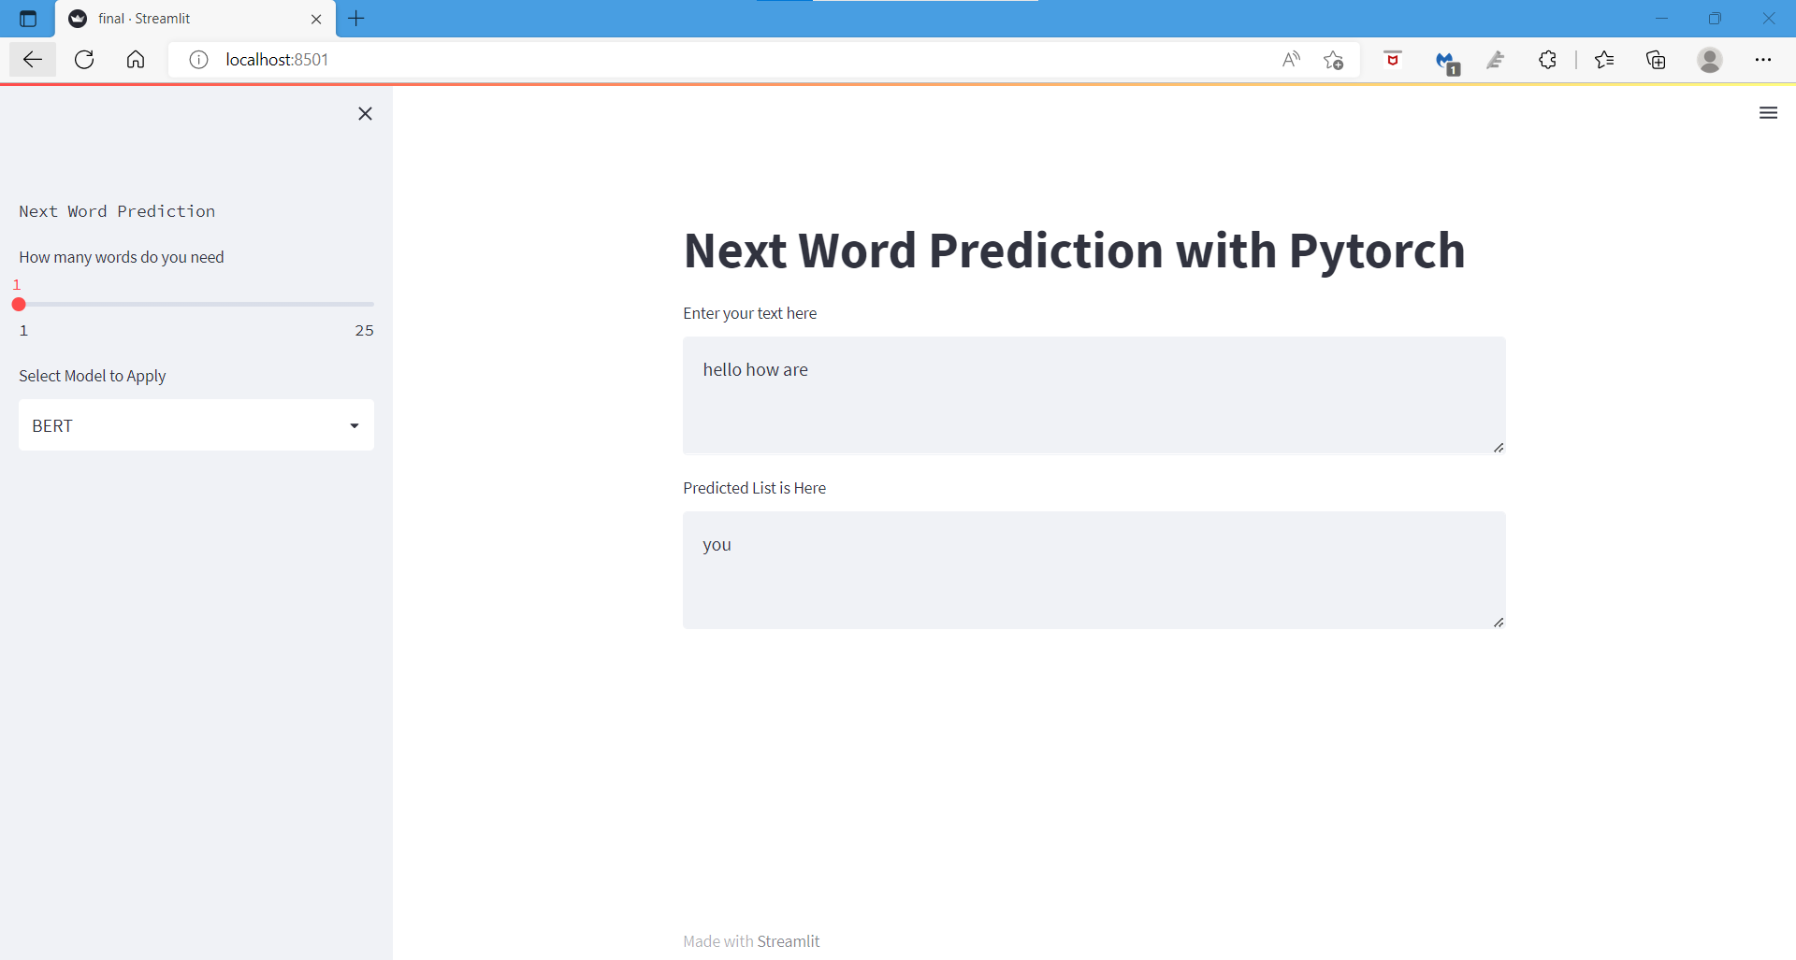

1. Examples:

